Minnesota Academy of Reading
January 10, 2022
3:00 pm
Virtual link: https://minnstate.zoom.us/j/99880075355
Passcode: MAR

MAR Mission:
The purpose of this council shall be to (1) provide an opportunity for members to actively engage in the process of sharing and testing professional ideas; (2) engage in service functions of instruction, consultation, and evaluation.

Attendees: Joan Sax-Bendix, Debbie VanOverbeke, Debra Peterson, Katie Barofsky, Kate Kelly

Reports:
Secretary: sent with the agenda
Treasurer: no change

Business:
- January Symposium- tech check with Joan at 4 pm- Katie
  - Panel update- Michelle Sandler is ready to attend, administrator, Higher Education- Lisa Krall (Joan invite)
  - State of the State presentation confirmed (Deb) haven’t heard about whether recording or in real time. Deb will send link if she gets a link to the recording.

Panel Questions:
- What professional learning have you had in the last 2 years about the Science of Reading and foundational reading skills? Please give an example.
  - If none, what questions do you have or have you heard from colleagues about the Science of Reading and foundational reading skills?
- Did you do your professional learning on your own or with a group of colleagues?
- How have you applied this knowledge in your current role?
- What kind of support have you experienced at your site as you have been refining your instructional practice and leadership?
- What other thoughts do you have about current trends in literacy education and practice?

  - Minnesota Academy Recording- Joan send invitation to all and then Registration link to Debbie and Katie
  - Google Folder link- Joan will share folder with everyone, already populated
  - Email reminders- Joan send on Friday, January 13
  - CEUs- Spring Mixer and January Symposium (evaluation form needed)
  - Book give away- Joan
  - Standards break out rooms: Unpacking new K12 ELA standards- primary (K-2)- Deb/Lisa, intermediate (3-5)- Kate/Katie, ms (6-8) hs (9-12) - Debbie/Annika
Identify areas based on sciences of reading/connect to pd/ connect to new standards.
Unpacking the Standards:
- What is your current experience with the new MN ELA standards?
- As you look across the grades at anchor standard 1 what do you notice about the developmental progression of skills?
- If you are a MS or secondary teacher, how do you see these foundational skills impacting the older students’ abilities to access content area text?
- How do current practices at your site align with the new Reading anchor standard 1 and benchmarks?
- In your current practice, what might be missing or need to be revised to better align with the new Reading anchor standards?
- How can MAR support MN educators with the implementation of the new ELA standards? (idea note-taking)

- LETRS legislation conversations/actions – (Lisa)- Tabled
- Spring Mixer- “Literacy Chats”- free event- send to Deb for MRA social media- book give away plug (Joan will send to Deb), Book drawing- MN book award (Kate will take care of this- finalists) - Children’s and Middle Level books suggestion
April 25th 4-5:30 pm – Virtual link
- 1 or 2 items to share, Standards link, Opportunity to share literacy resources- article, book activities with others- children’s books
- Share a resource to teach the standard
- Informal
- HELP Updates (Deb & Joan)
Feb 1st is kickoff Principal’s Academy thru U of M, eventually will have access to a website to all presentation, you may use any of it.
Abbey Payeur- Professional Book Club option

- MRA Updates (Deb)
A week from Saturday- should be a leadership meeting- Joan- virtual event, instead of Joan…Lisa Krall??Katie Barofsky??
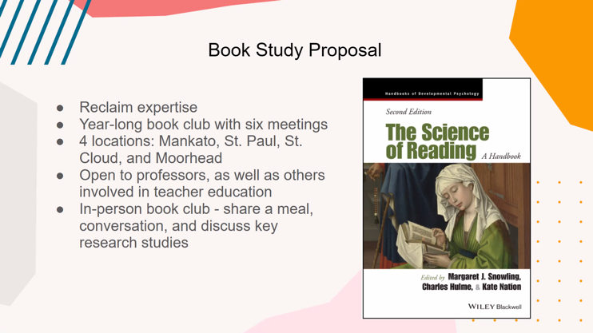
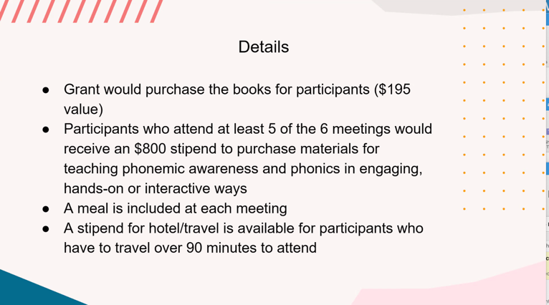

- LiRN (Deb)
Dr. Alfred Tatum- Feb 17, 9-12- access to video
Virtual event
Members access to recording.

- Honor Council Application- (work July 2022-June 2023)
Submission
This year’s needs:
  - Part 1: Service to Chapter Members
    - Long Range Plan
    - Brochure review
    - Website/social networking- need help
    - Highlights newsletter- Book reviews of literature, elementary student writing projects, research- online reading, professional resource- February

  - Part 2: Service to Local Community
    - Summer Book Club leaders- Multilingual leaders By Lori Helman, ebooks with discussion guide- Oct 4th webinar
    - Celebrate Literacy
    - Community donations- Lisa and Joan
    - Supporting Future/New Educator- 1-yr membership to ________students- graduate or undergraduate.
Identify a new/recent graduate with an institution with membership to IRA, MRA, & MAR. Kate will process reimbursement. $35
New to profession and invite to Symposium & Spring Mixer- Jordyn Walters, WSU (Joan will take of this)
  - Part 3 Partnership with State/Provincial Chapter and ILA
    - Membership Outreach
    - Help Global Fund-
    - Worldwide Literacy- Wendy (Jamaica)- collection date?

- Follow-up from December meeting- Joan send invite to Feb mtg., list of researcher authors
  - Abby Payeur information
  - Textbook list
  - New book club idea- Abby- role of MAR?

- Spring Semester meeting dates
  - Feb 14
  - March 14
  - April 11
  - May 9

